PROJECT 6 – WINDOWS SYSTEM HARDENING
Student Submission Template
Student Name: Bryan Mungai
Course / Section:
Date: 4/15/26
Screenshot 1: PUA protection enabled
[PASTE SCREENSHOT HERE]
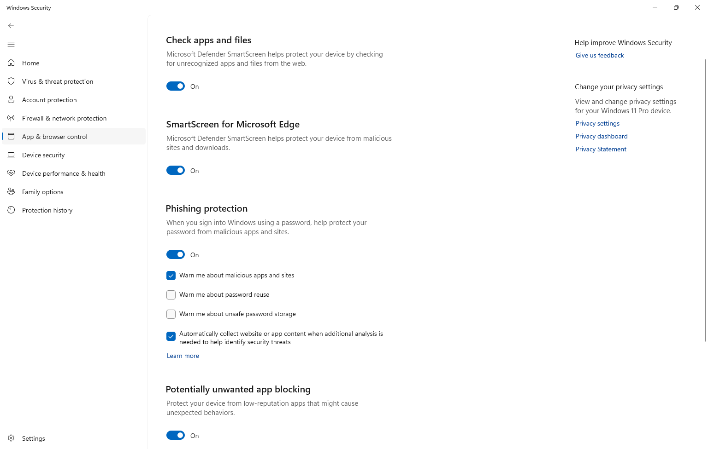
Screenshot 2: Tamper Protection ON
[PASTE SCREENSHOT HERE]
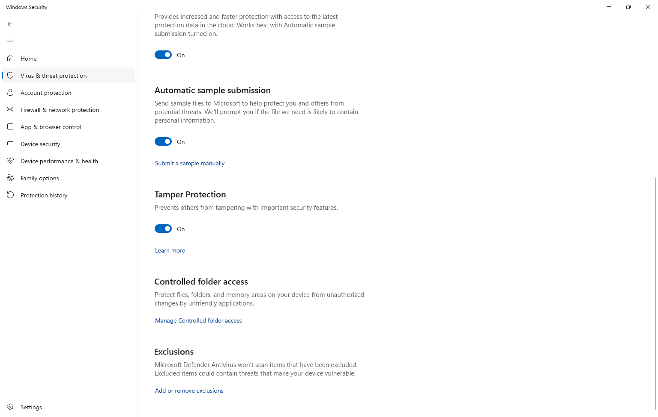
Screenshot 3: Service startup type set to Manual
[PASTE SCREENSHOT HERE]
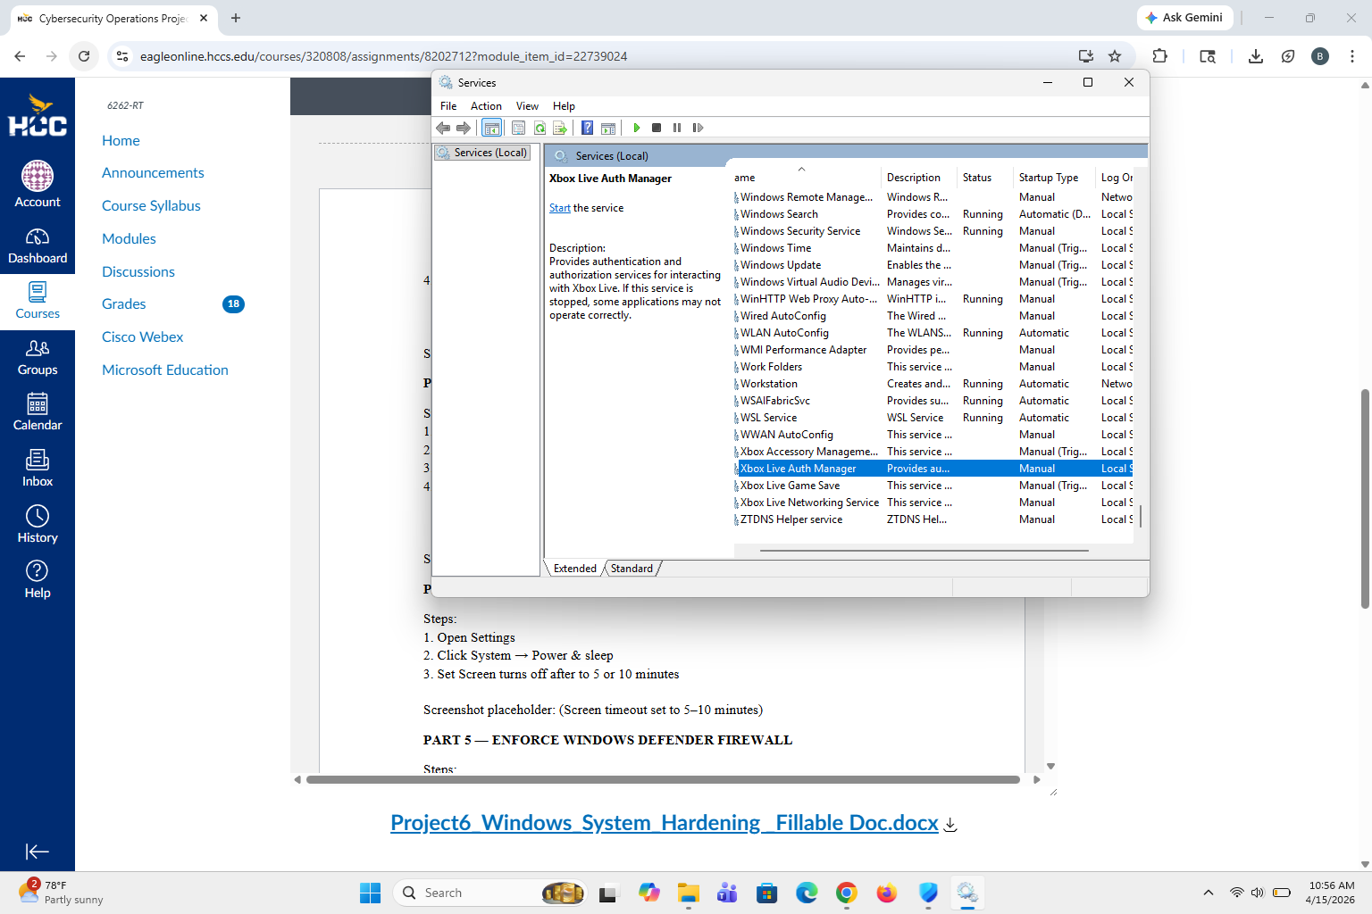
Screenshot 4: Screen timeout set to 5–10 minutes
[PASTE SCREENSHOT HERE]
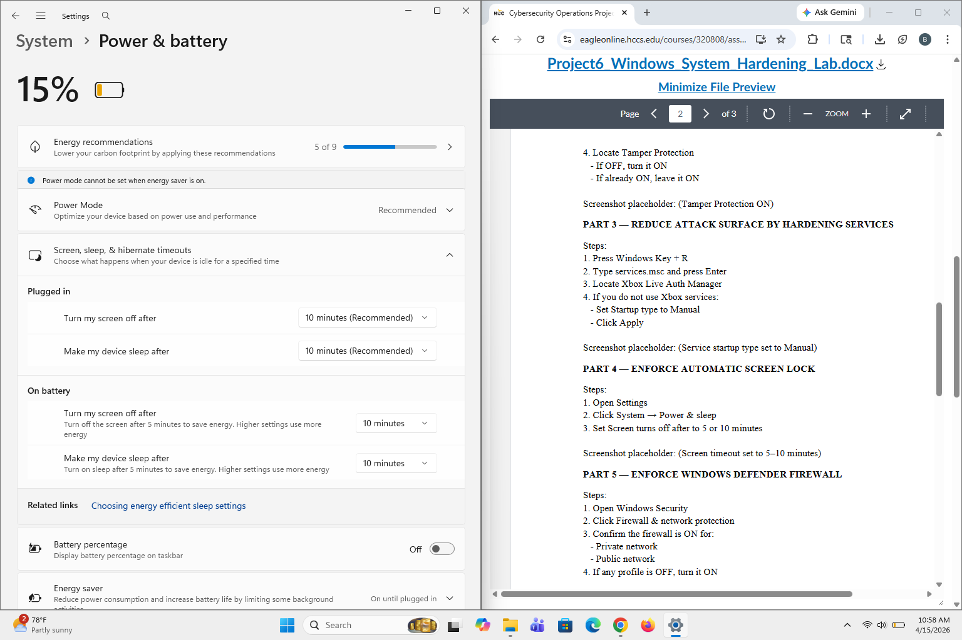
Screenshot 5: Firewall ON for Private and Public networks
[PASTE SCREENSHOT HERE]
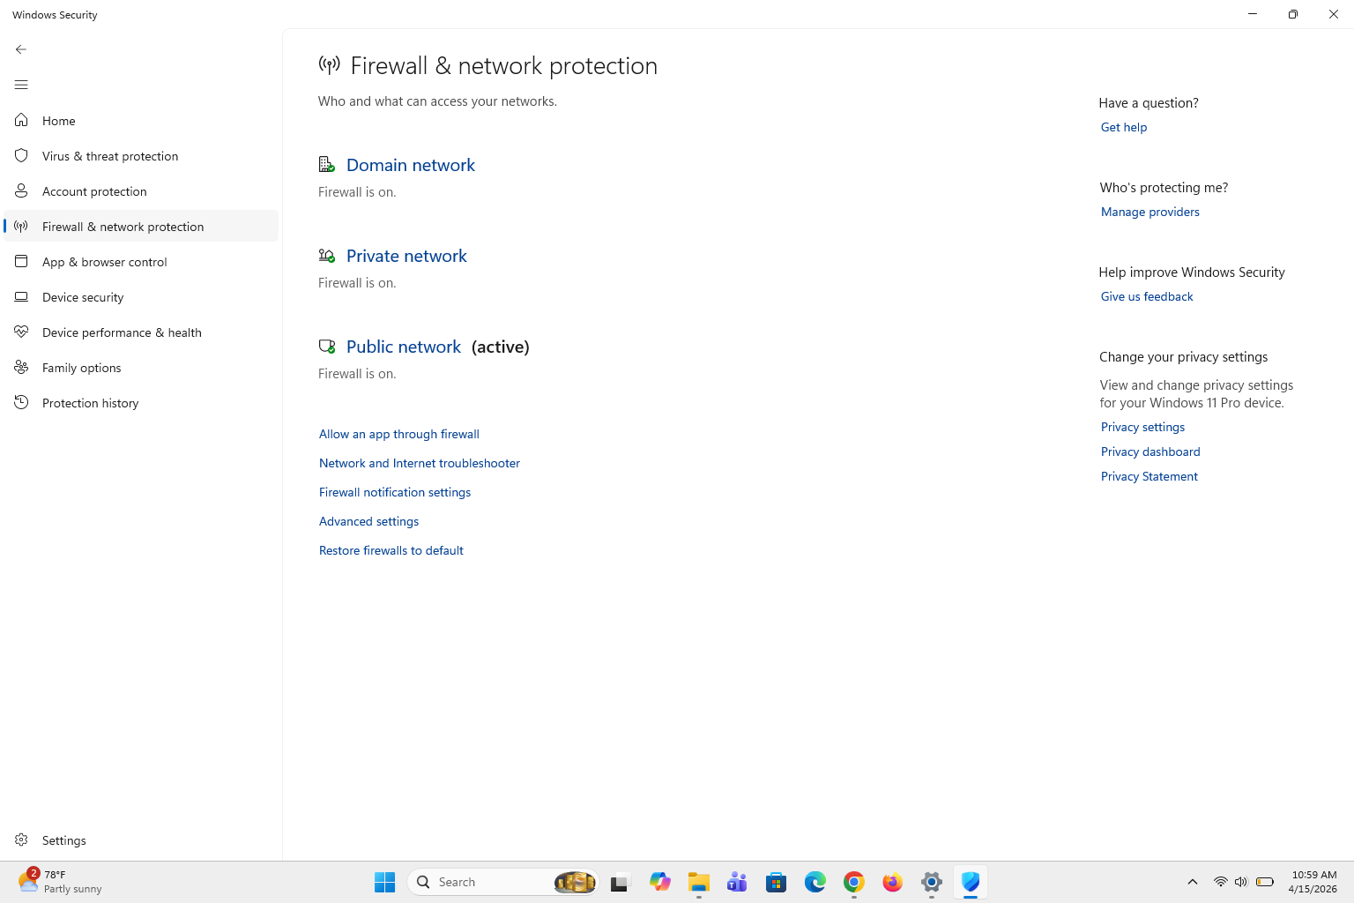
Reflection Responses
1. Identify one setting that was weaker before this project and explain how you hardened it. (75–120 words) - One setting that was already configured but still important to verify was the Windows firewall. Although it was already enabled before the project, confirming that it was active across all network profiles (public, private, and domain) ensured the system was properly protected. By reviewing this setting, I reinforced my understanding of how the firewall filters incoming and outgoing traffic to block unauthorized access. This validation step is part of system hardening because it confirms that critical protections are in place and functioning correctly, reducing the risk of network-based attacks.
2. What risk does this change reduce? (75–120 words) - This change reduces the risk of unauthorized access and network-based attacks. By ensuring the firewall is enabled on all network profiles, the system is protected from unwanted incoming connections and potentially malicious traffic. This helps prevent attackers from exploiting open ports or vulnerabilities to gain access to the system, reducing the likelihood of data breaches or malware infections.
3. Why is system hardening important even when no attack is visible? (75–120 words) - System hardening is important even when no attack is visible because many threats are not immediately detectable. Attackers often scan systems for vulnerabilities and may exploit weak configurations without showing obvious signs. By hardening the system in advance, you reduce the number of potential entry points and make it more difficult for an attacker to succeed.

